md;id G+gjp jkpo;f; fiyf;$lk; itj;ntj; tshfk;

fhu;j;jpif khjg;ghlj;jpl;lk;
fy;tpahz;L 2023 - 2024
Mz;L 6

fpoik -- 44 ghlk; 4 : cwitg;;NgZNthk; njhlu;r;rp
jpfjp  04.11.2023  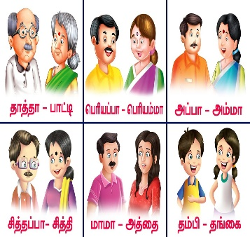 | fhiy tzf;fj;Jld; tFg;G Muk;gkhFk;  ghlk; 4 : cwitg;;NgZNthk;  - kPl;ly;  - nrhy;tnjOJjy;  ,yf;fzk; : nrhy;ypa cWg;Gfs;  - thrpj;jy;  - tpsf;fk; nfhLj;jy;  - gapw;rp nra;jy;  FO nraw;ghL : nray; 4 (gf;fk;- 23)
tPl;LNtiy | kjpg;gPL 1- Maj;jk; nra;jy;  ghlq;fs; 1>2>3>4
fpoik -- 45 kjpg;gPL 1
jpfjp  11.11.2023 | fhiy tzf;fj;Jld; tFg;G Muk;gkhFk;  kjpg;gPL 1  ghlq;fs; 1>2>3>4
tPl;LNtiy | ghlk; 5 : Mopf;Fkud; Mde;jd;  - thrpj;jy;  nra;ahj gapw;rpfis nra;jy;
fpoik -- 46 ghlk; 5 : Mopf;Fkud; Mde;jd;

jpfjp  18.11.2023  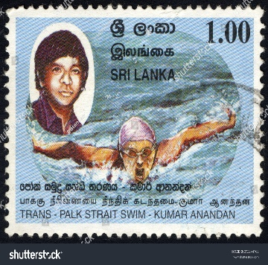 | fhiy tzf;fj;Jld; tFg;G Muk;gkhFk;  ghlk; 5 : Mopf;Fkud; Mde;jd;  - thrpj;jy;  - tpsf;fk; nfhLj;jy;  - gapw;rp nra;jy;  gz;ghL mwpNthk;  - thrpj;jy;  - tpsf;fk; nfhLj;jy;  NgRNthk;: FOr; nraw;ghL (gf;fk; 30)
tPl;LNtiy | ghlk; 5 : Mopf;Fkud; Mde;jd;  - thrpj;jy;  - nrhy;tnjOJjy; - Maj;jk; nra;jy;  ghlk; 5 :nray;;;E}y;  - nray; 4> nray; 5
fpoik -- 47 ghlk; 5 : Mopf;Fkud; Mde;jd; njhlu;r;rp

jpfjp  25.11.2023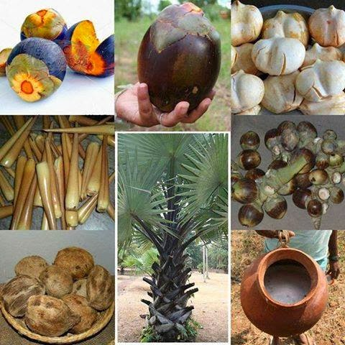 | fhiy tzf;fj;Jld; tFg;G Muk;gkhFk;  ghlk; 5 : Mopf;Fkud; Mde;jd;  - kPl;ly;  - nrhy;tnjOJjy;  ,yf;fzk; : ngau;r;nrhy;  - thrpj;jy;  - tpsf;fk; nfhLj;jy;  - gapw;rp nra;jy;  FO nraw;ghL : nray; 6 (gf;fk;- 29)
tPl;LNtiy | miuahz;Lj; Nju;T - Maj;jk; nra;jy;  - thrpj;jy; - ghlq;fs; 1>2>3>4>5  - nra;ahj gapw;rpfis nra;jy;  - vOjhj fl;Liufis vOJjy;
Nehf;fk; | - jkpo; cwTKiwfis mwpe;Jnfhs;sy;.  - Mopf;Fkud; Mde;jidAk; mtupd; jpwtpidfisAk; mwpe;Jnfhs;sy;  - ,yf;fzk;: ngau;r;nrhy;- njspthf tpsq;fpf;nfhs;sy;

jfty;fs;:
- 11.11.2023 - kjpg;gPL 1
khtPuu; Xtpag; Nghl;b
- 23.11.2023 - jkpoPo Njrpa khtPuu; ehs; - epidTr; RlNuw;wy;

Fwpg;G:
Nkyjpf jfty;fs; kw;Wk; khw;wq;fis clDf;Fld; mwpe;J nfhs;s ,izaj; jsj;jpw;F nry;tNjhL itgu; FOtpy; jfty;fisg; ghu;itaplTk;.

