md;id G+gjp jkpo;f; fiyf;$lk; itj;ntj; tshfk;.

fhu;j;jpif khjg; ghlj;jpl;lk;
fy;tpahz;L: 2023 - 2024
Mz;L 4

fw;gpj;jy; fhyk;: 4 fpoikfs;
fpoik : 44 ghlk; 5 - njhlu;ghlw; fUtpfs;
04/11/23 | fhiy tzf;fj;Jld; tFg;G Muk;gkhFk;.  glj;ijg; ghu;j;J fye;Jiuahly;.  nrhw;fs; mwpNthk;. ghlj;ij thrpj;J tpsf;fkspj;jy;.  khztu;fs; jdpj;jdpahf thrpj;jy;;. ghl tpdhf;fSf;F tpilaspj;jy;.  nray;E}y;: 5 nray;: 2> 3> 4 nra;jy;.  FOg;Nghl;b
tPl;LNtiy | nrhy;tnjOJjy;: ghlk; 5 - njhlu;ghlw; fUtpfs;  nray;E}y;: nray;: 1 (gf;fk;18) nra;jy;.  5 nrhy;ypaq;fs; vOJjy; (nrhw;fs; mwpNthk; )  thrpj;jy; - 15 epkplq;fs;.
fpoik: 45 ghlk; 5 ghlk; - njhlu;ghlw; fUtpfs; (njhlu;r;rp)
11/11/23 | fhiy tzf;fj;Jld; tFg;G Muk;gkhFk; .  gz;ghL mwpNthk;. ( Fws; 99) tpsf;fkspj;jy;  nrhy;tnjOJjy; - ghlk; 5  ,yf;fzk; mwpNthk;. ( vz;> ,lk;)  nray;E}y;: 5 nray;: 5> 6 nra;jy;
tPl;LNtiy | thrpj;jy;: 15 epkplq;fs;. (ghlk; 6 Mbg;gpwg;G )
fpoik: 46 ghlk; 6 - Mbg;gpwg;G
18/10/23  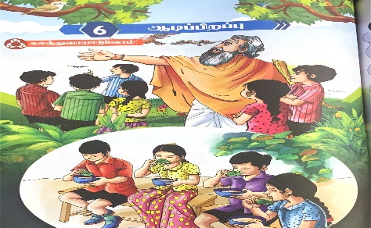 | ghlk; 6 Mbg;gpwg;G fhiy tzf;fj;Jld; tFg;G Muk;gkhFk;.  glj;ijg; ghu;j;J fye;Jiuahly;.  nrhw;fs; mwpNthk;. ghlj;ij thrpj;J tpsf;fkspj;jy;.  khztu;fs; jdpj;jdpahf thrpj;jy;;.  nray;E}y;: 6 nray;;: 2> 3> 4 (gf;fk; (24-26) nra;jy;.
tPl;LNtiy | Kbtilahj tpdhtpil kw;Wk; gapw;rpfs; nra;jy;.  thrpj;jy;. 15 epkplq;fs;.  nrhy;tnjOJjy; - ghlk; 6
fpoik: 47 ghlk; 6 - Mbg;gpwg;G (njhlu;r;rp)
25/11/23 | fhiy tzf;fj;Jld; tFg;G Muk;gkhFk;  nrhy;tnjOJjy; - ghlk; 6 Mbg;gpwg;G.  nray;E}y;: 6 nray;;: 5> 6 (gf;fk; 27-28) nra;jy;  FOg;Nghl;b
tPl;LNtiy | Kbtilahj nray;E}y; kw;Wk; gapw;rpfs; nra;jy;.  thrpj;jy; 15 epkplq;fs;.  Mbg;gpwg;G gw;wp 5 nrhy;ypaq;fs; vOJjy;.
milT | nkhoptsk; - njhlu;ghlw; fUtpfs; Mbg;gpwg;G gw;wp mwpjy;  ,yf;fzk; mwpNthk;.
Nehf;fk; | khztu;fSf;F gad;juf;$ba tifapy; xt;nthU ghl myFfisAk; mjd; gad;fisAk; mwpjy;.

jfty;fs; | - 11.11.23 - khtPuu; Xtpag;Nghl;b ( tFg;G 5> 6> 7 ,w;F ,lk;ngWk;)  - 25.11.23 – khtPuu; epidTr; RlNuw;wy;  - 27/ 11/ 23 – khtPuu; ehs;  ghlj;jpl;lj;jpy; ,Ug;gjpy; rpy khw;wq;fs; tuyhk;.

